**Create a Docker image and push it to Docker hub using CI-CD.  
Create a Docker file for a sample Node.js application and automate the process of building the Docker image and pushing it to Docker Hub using Jenkins file.**

**Login to aws console and create EC2 instance with security inbound ports 8080**

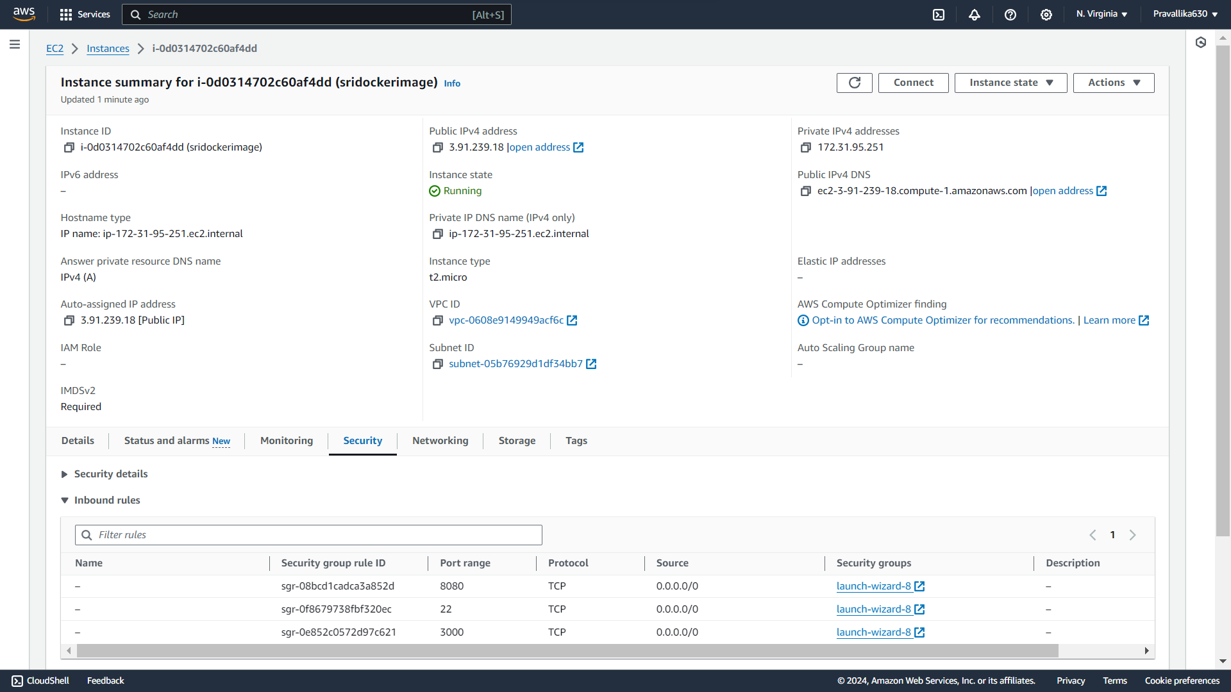

**Copy the ssh command**

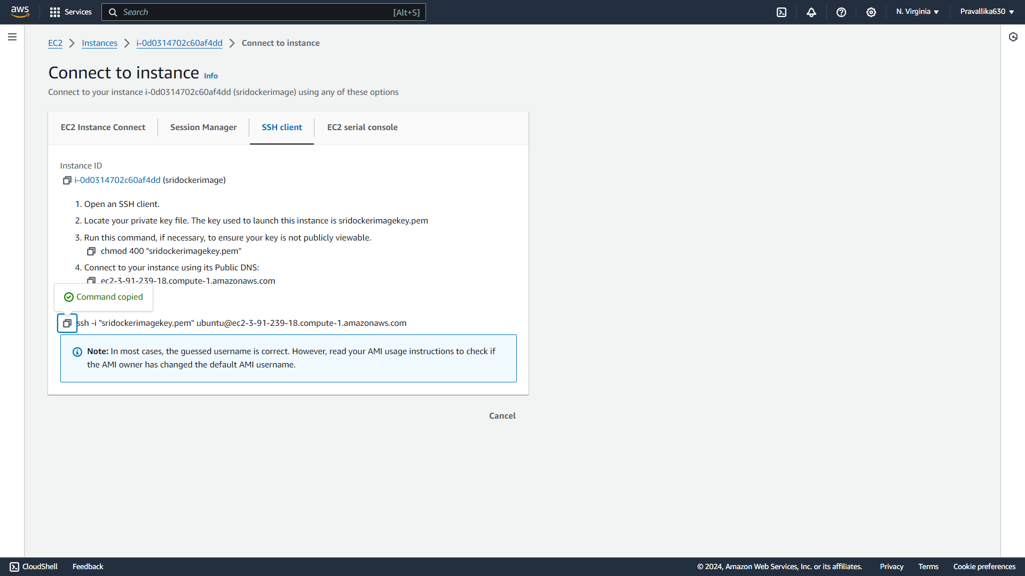

**Git bash the downloaded key pair with ssh command**

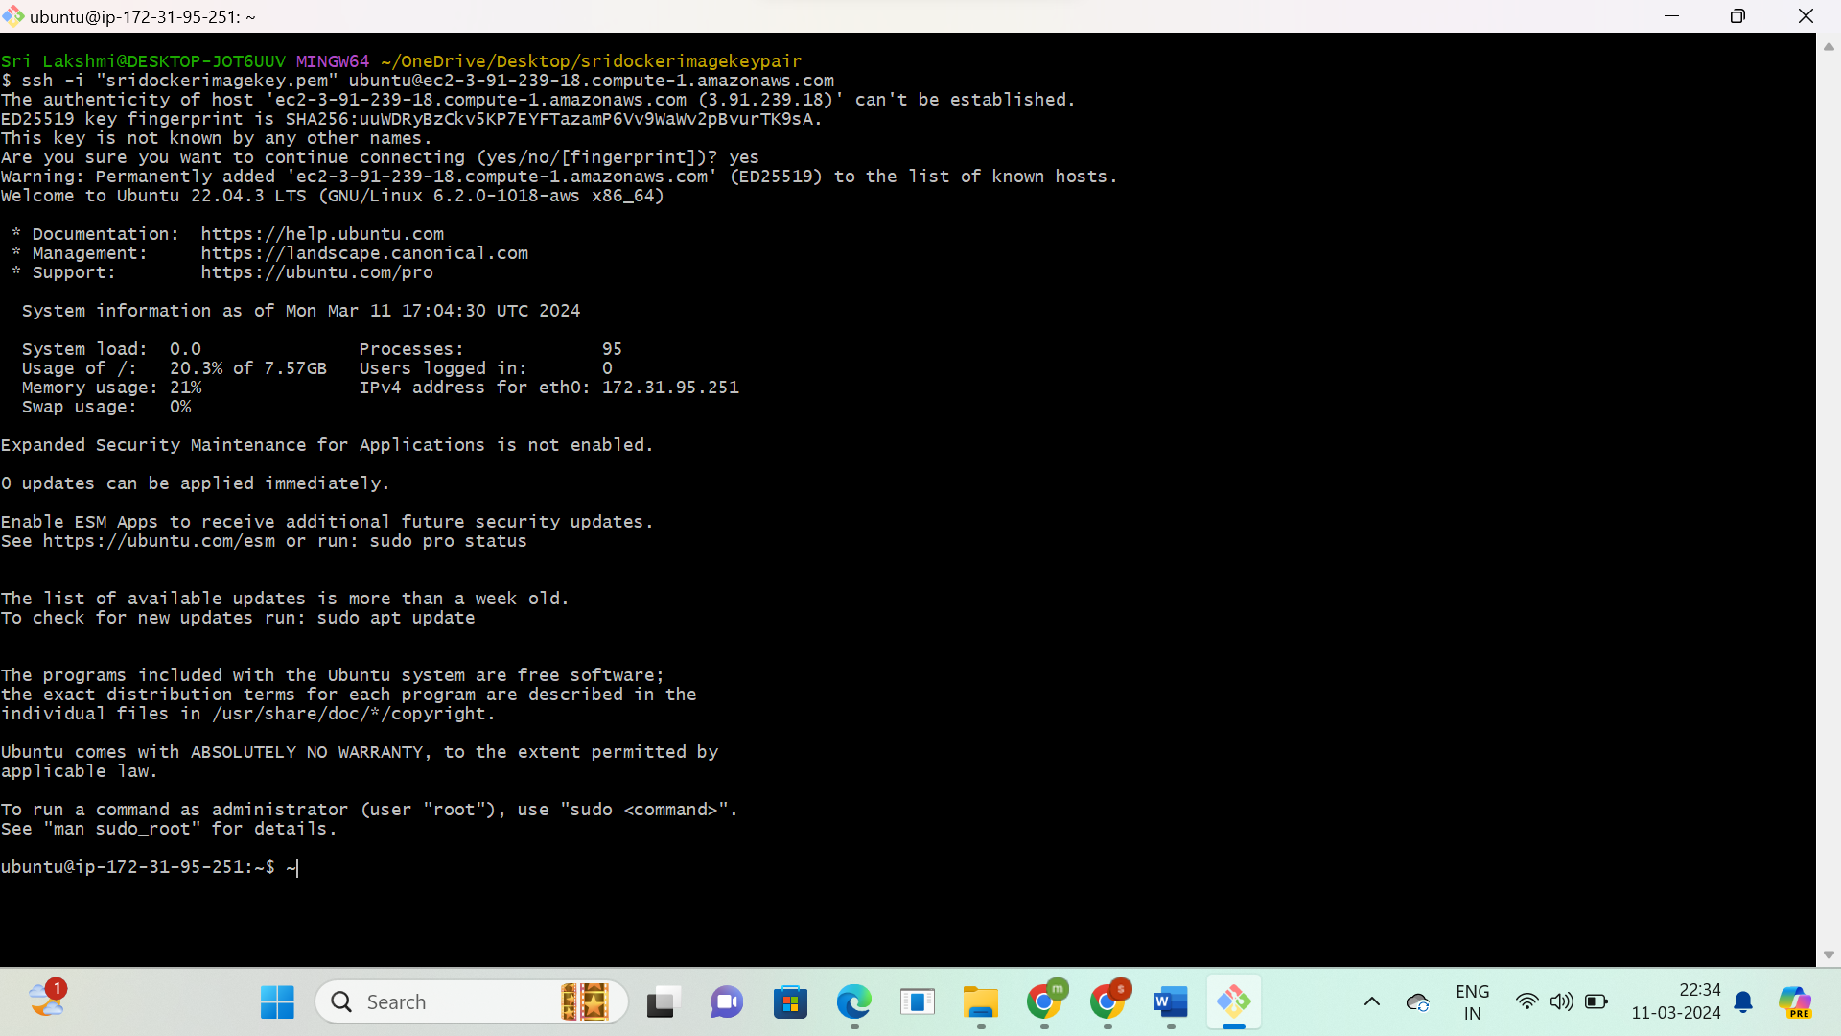

**Install java**

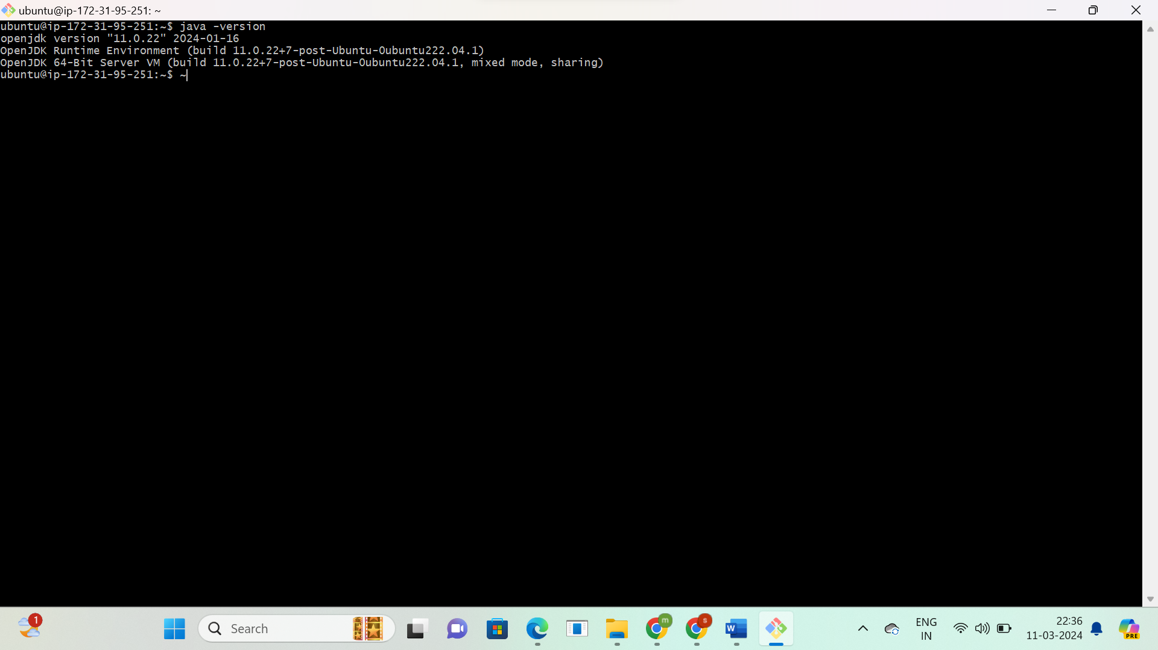

**Install jenkins**

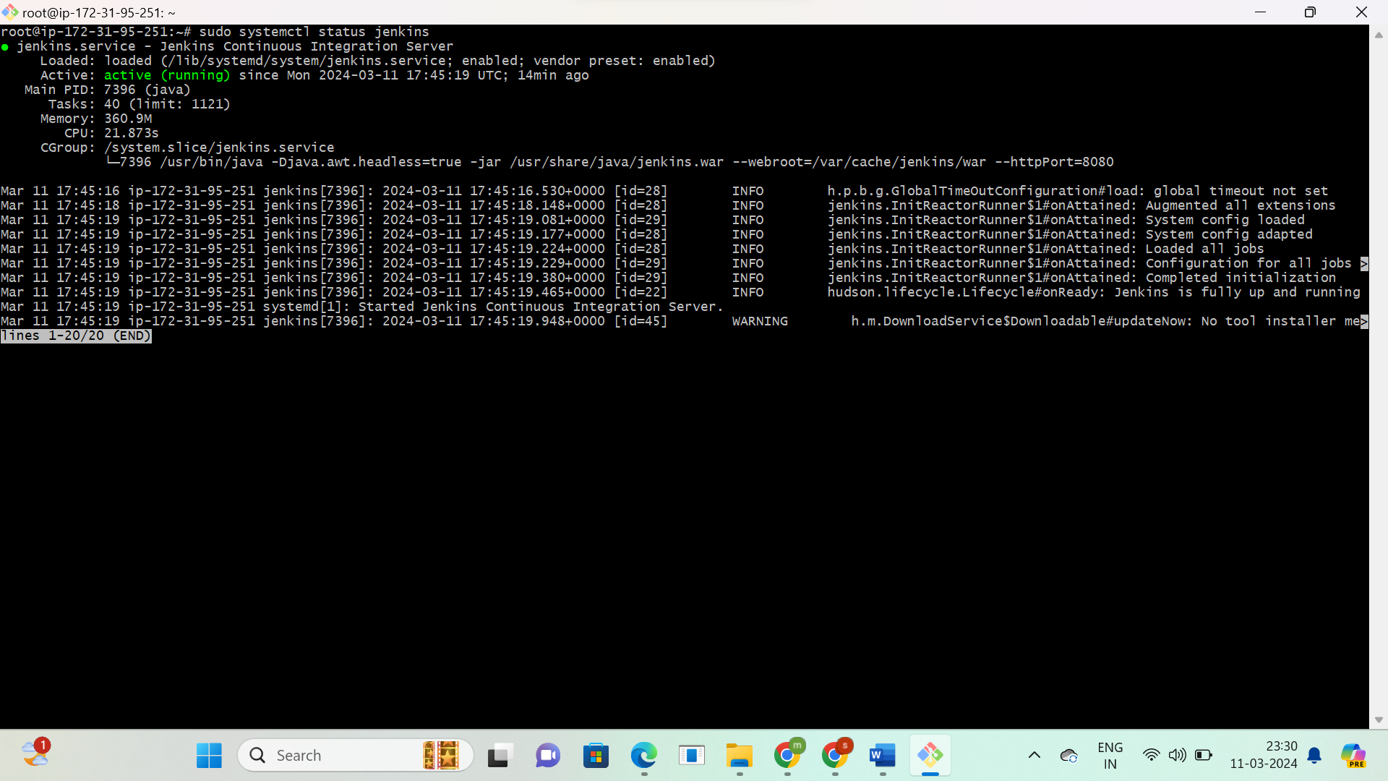

**Install docker**

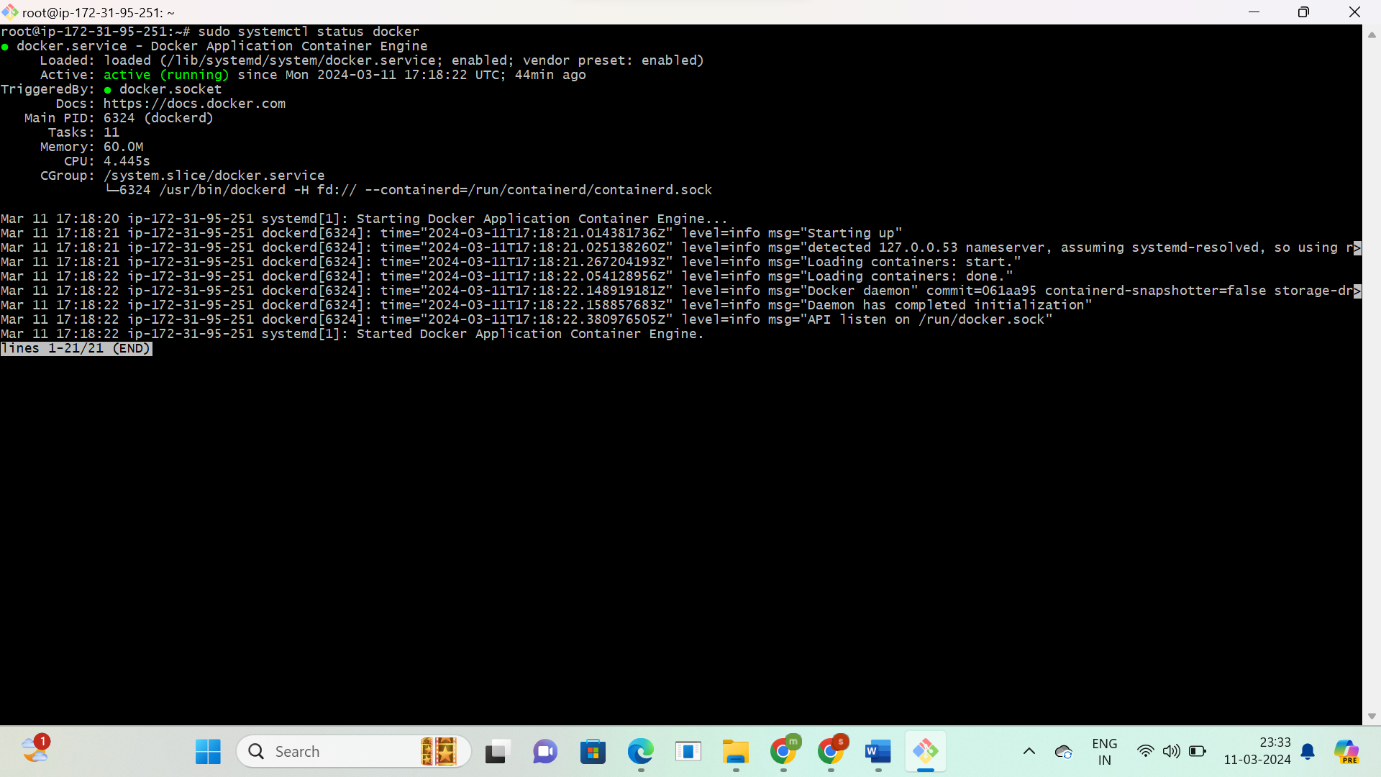

**Unlock the Jenkins server with public IP address:8080 port**

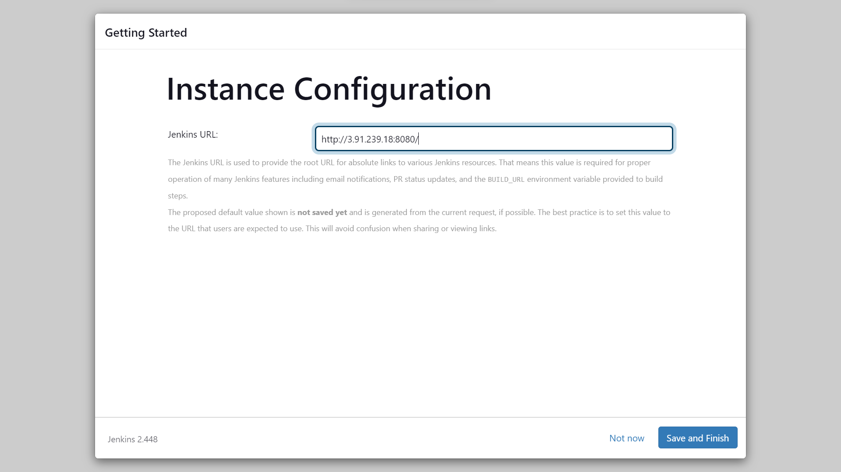

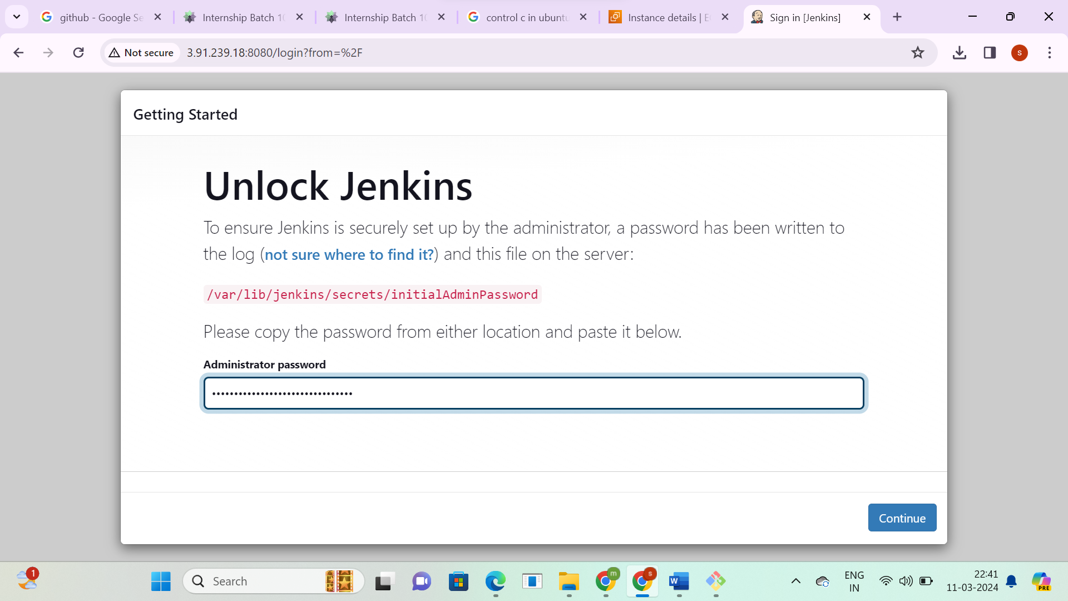

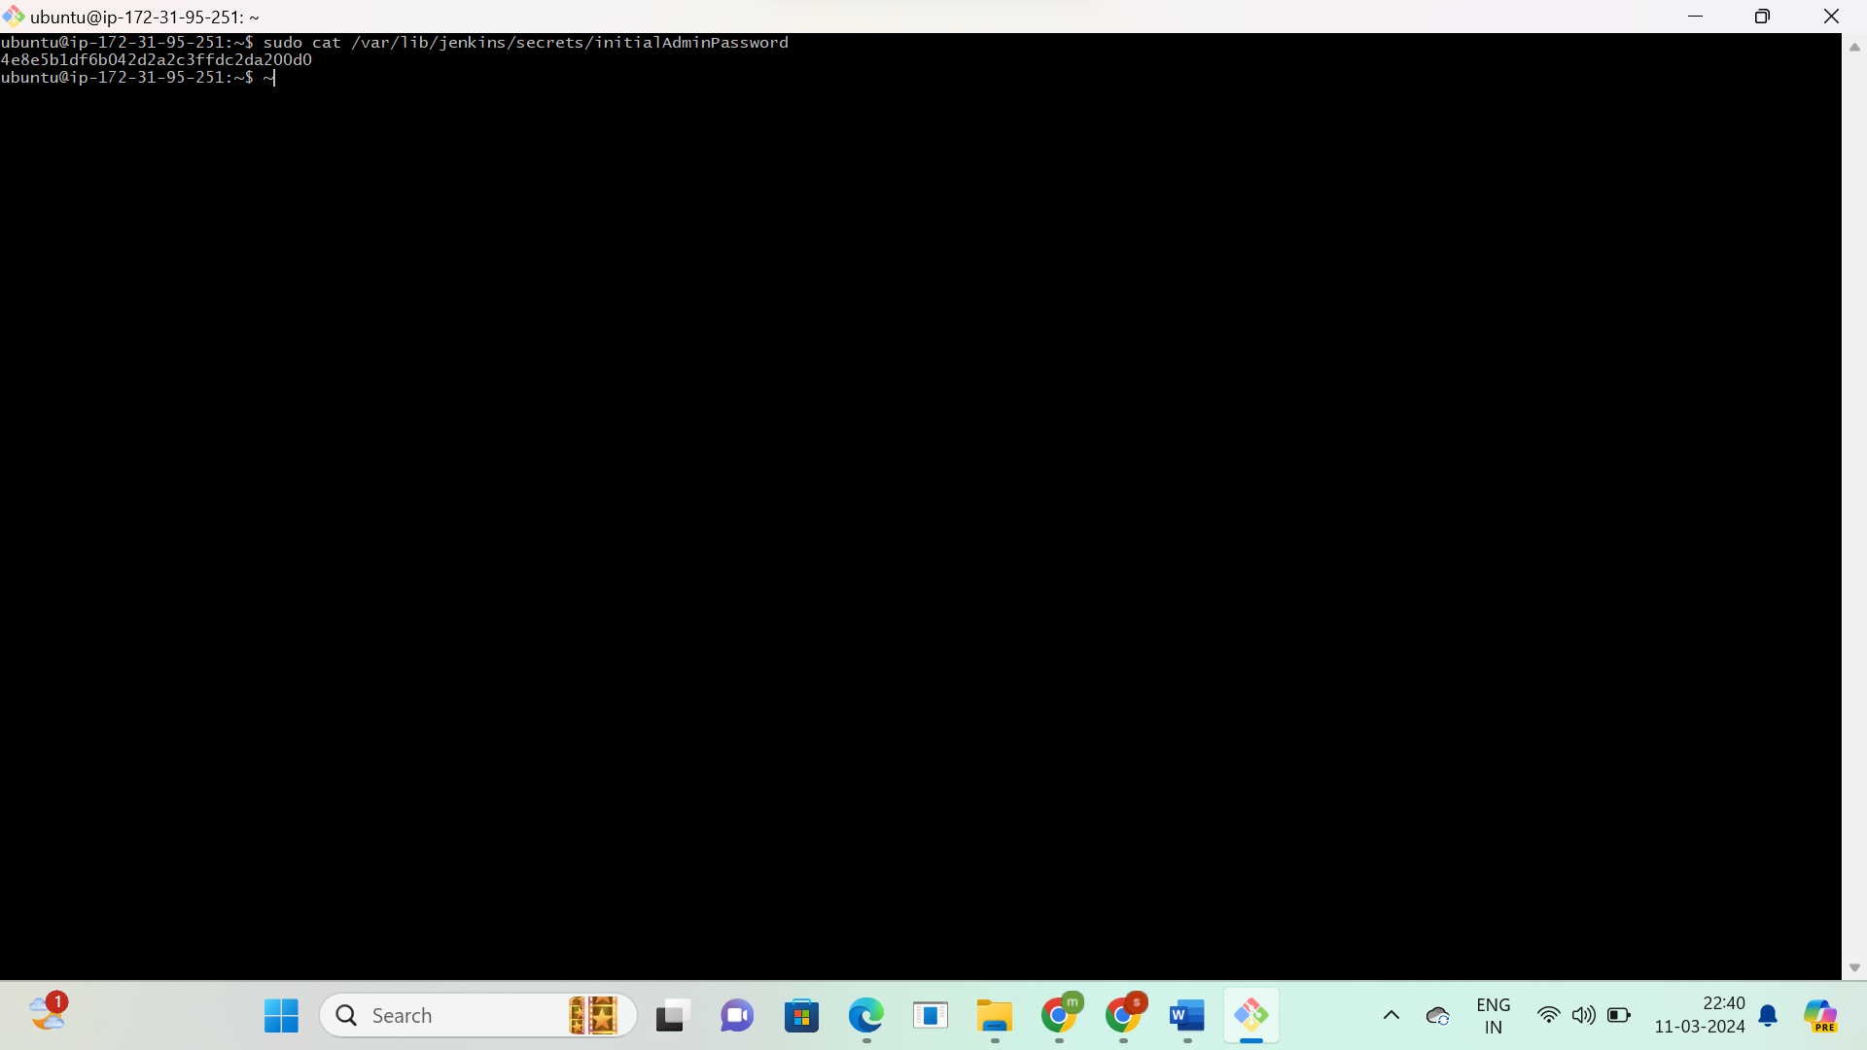

**Install Jenkins suggested plugins**

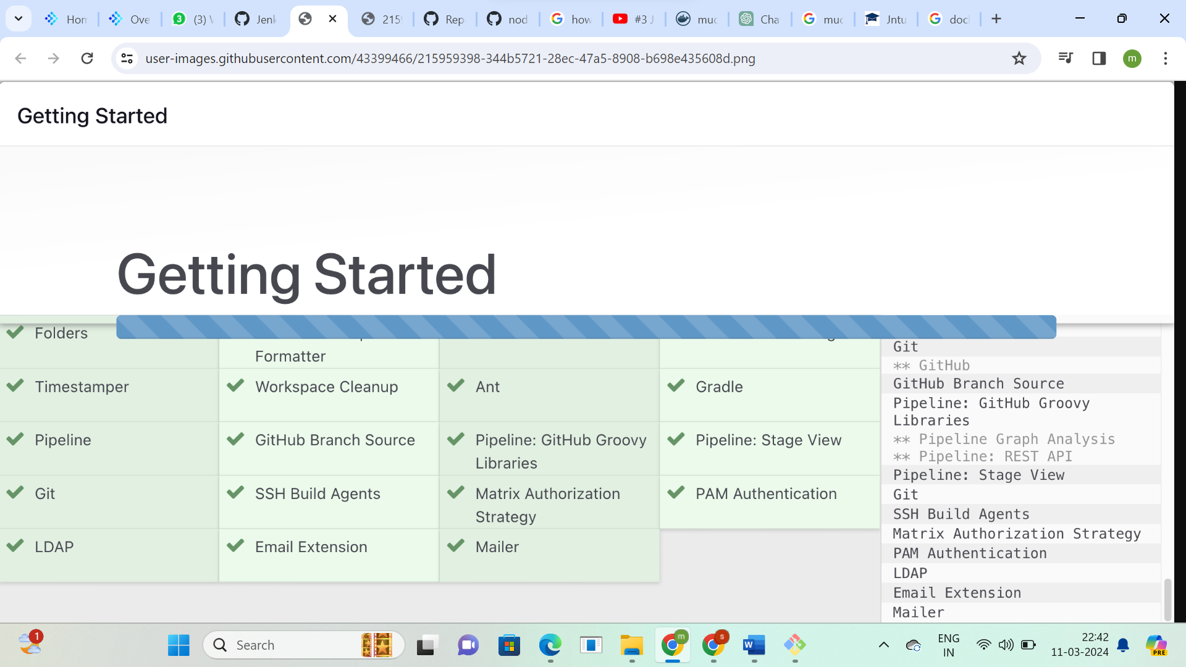

**Create Jenkins credentials and login to the Jenkins server**

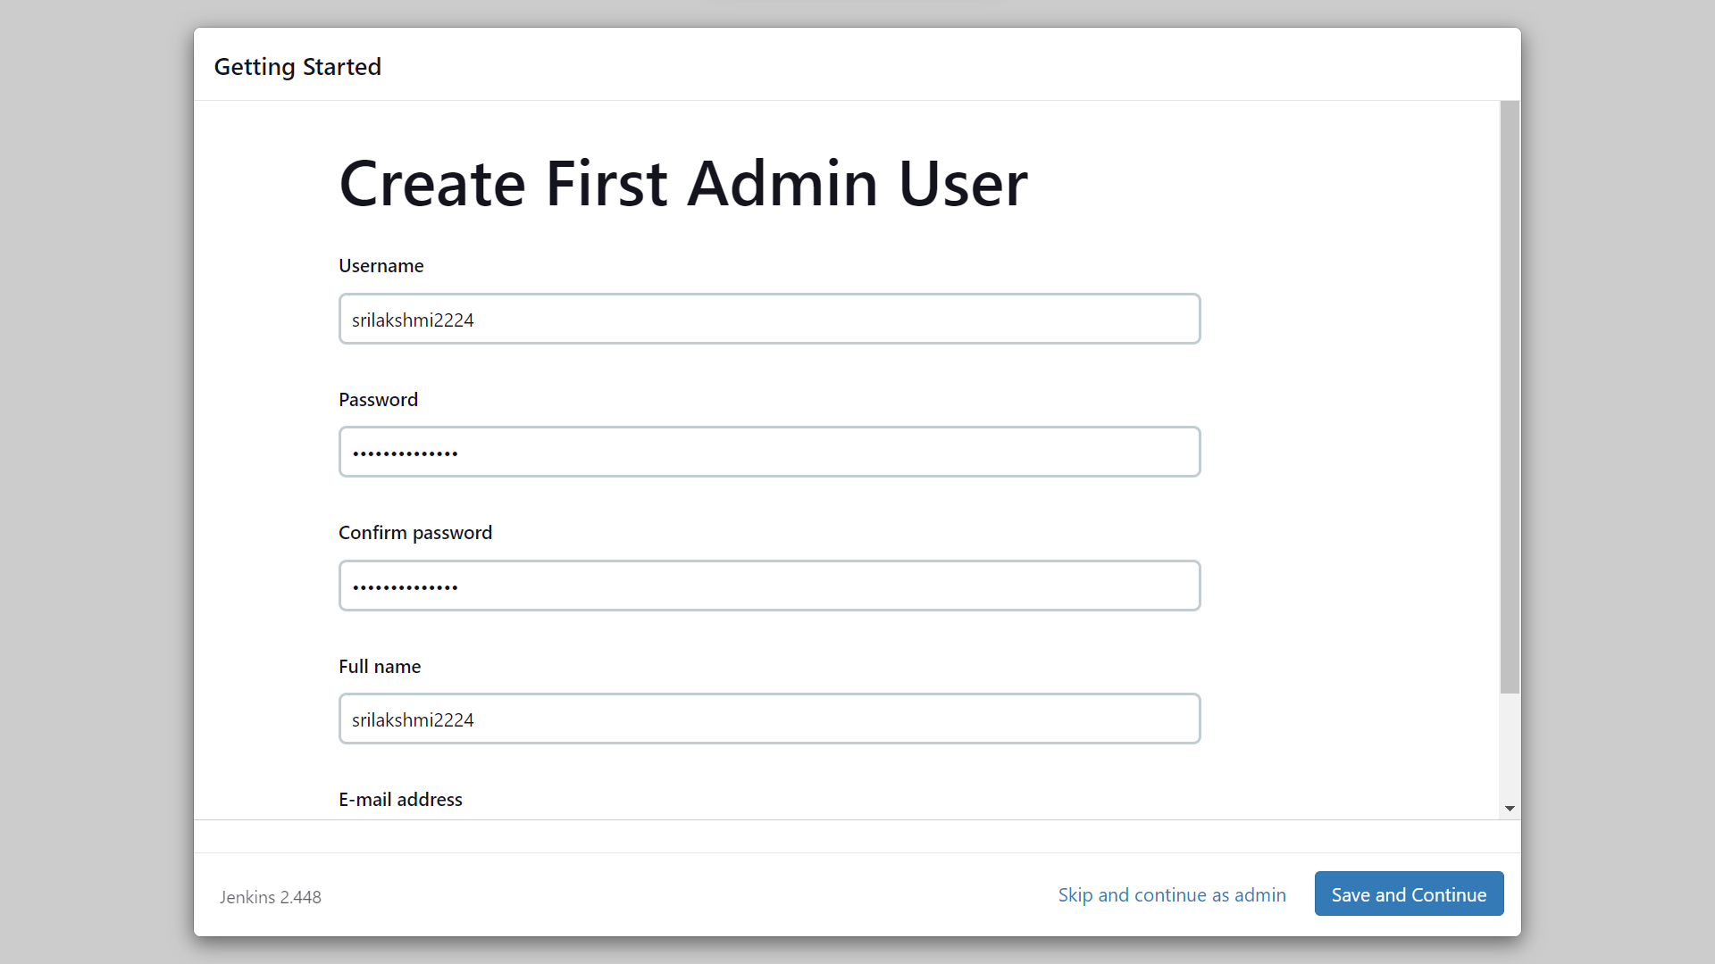

**This is the Jenkins dashboard now go to create job**

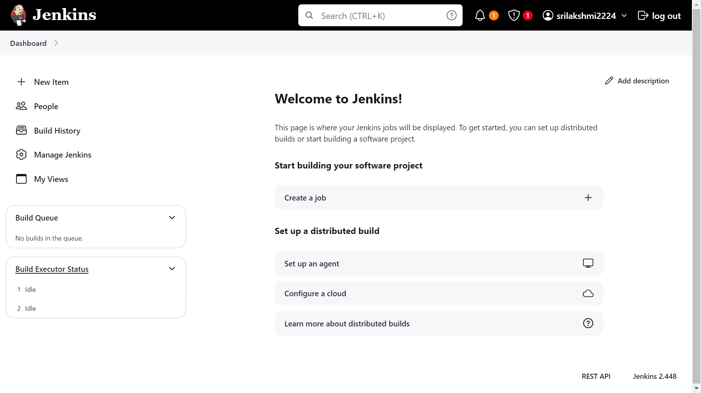

**Enter the name and select pipeline**

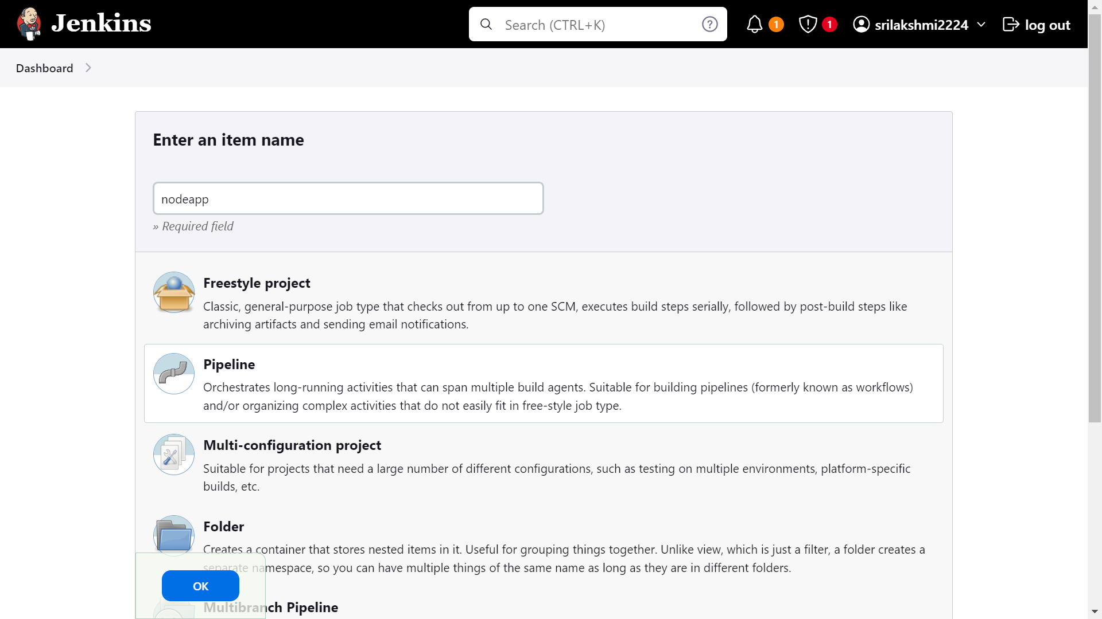

**Install Docker and nodejs plugins**

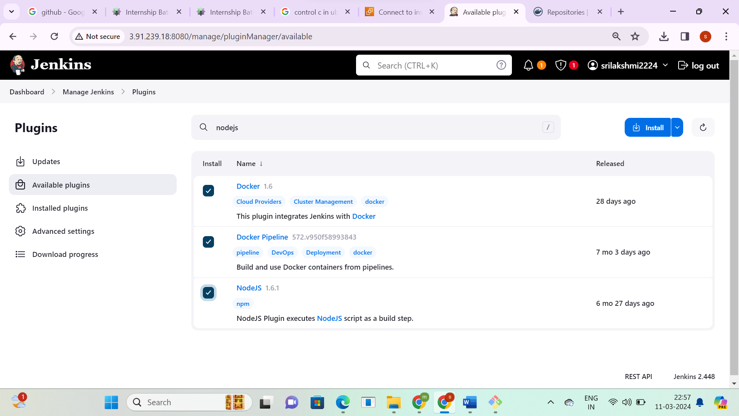

**These are the GitHub and Docker hub credentials**

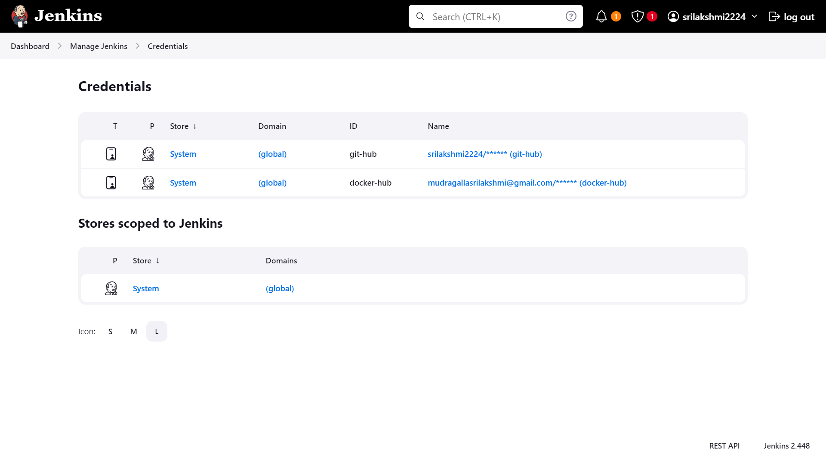

**Create Jenkins file, docker file scripts and push it into the GitHub   
Configure nodepipeline using the GitHub url, credentials and then click on build**

**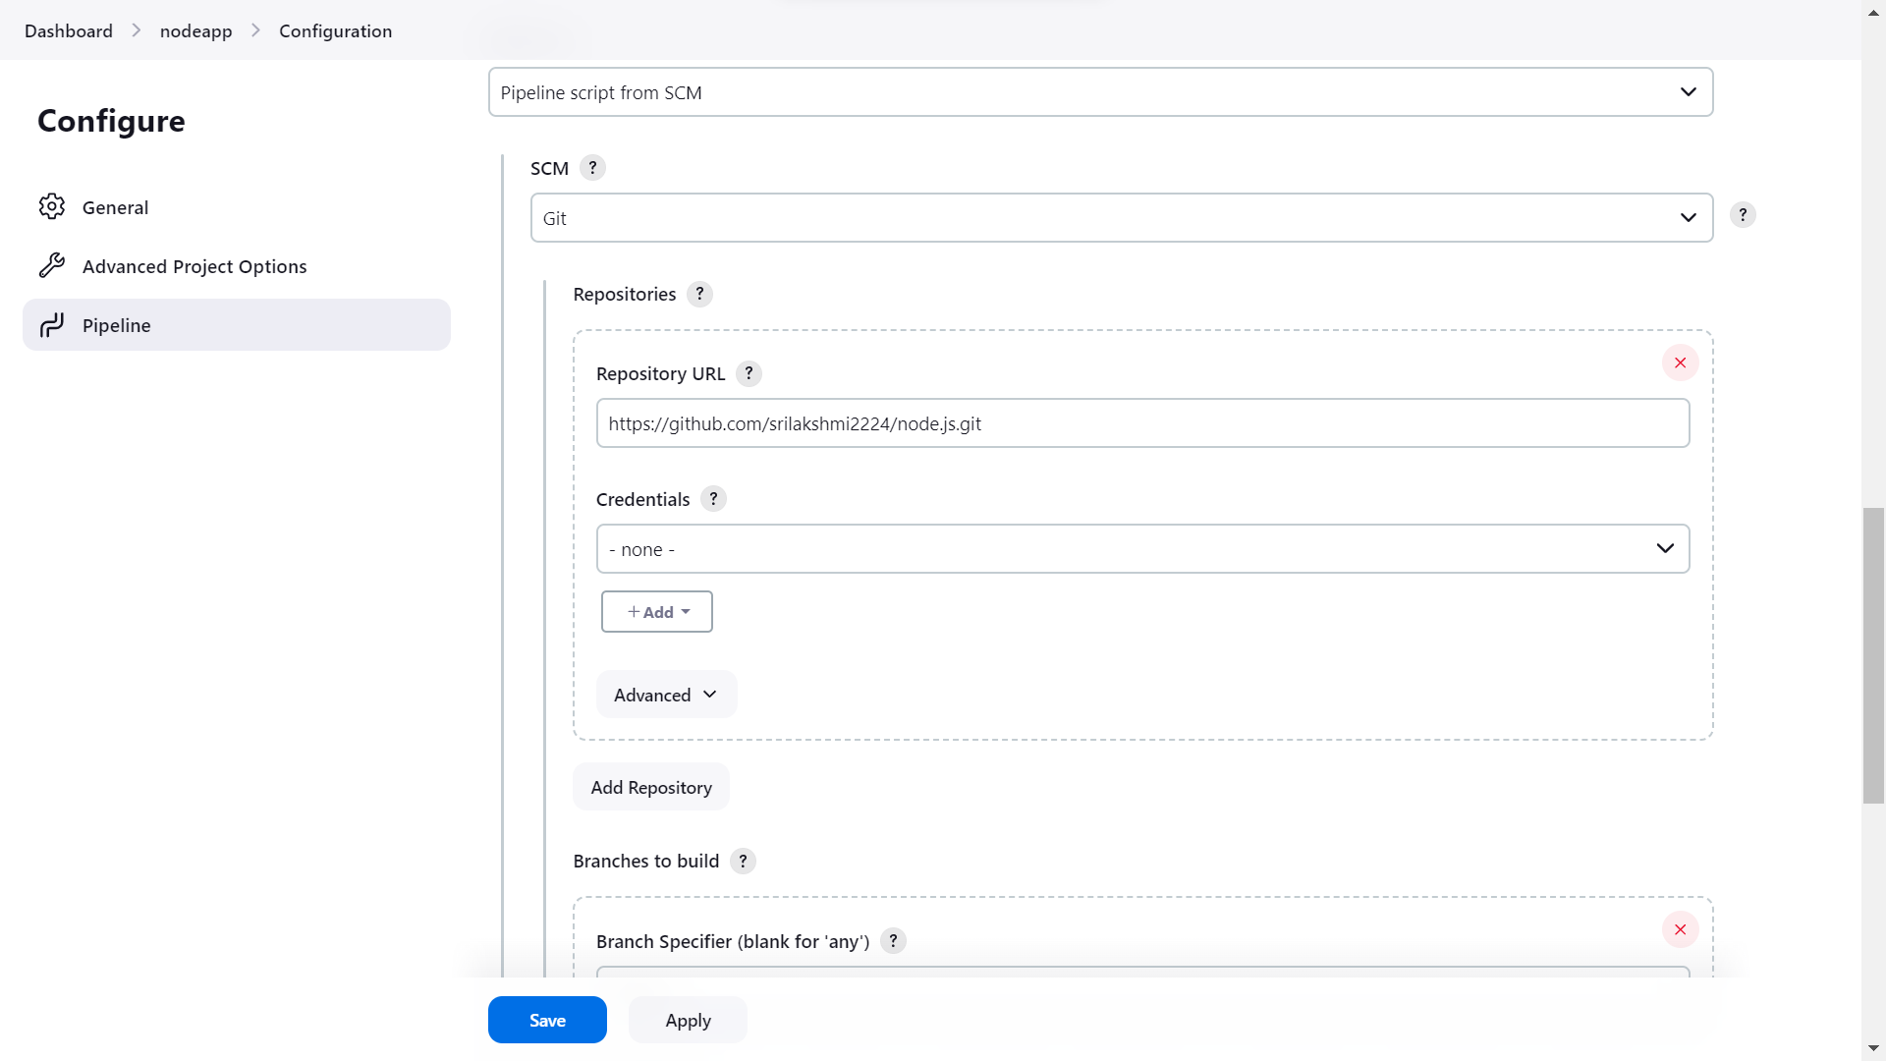  
The code was built successful**

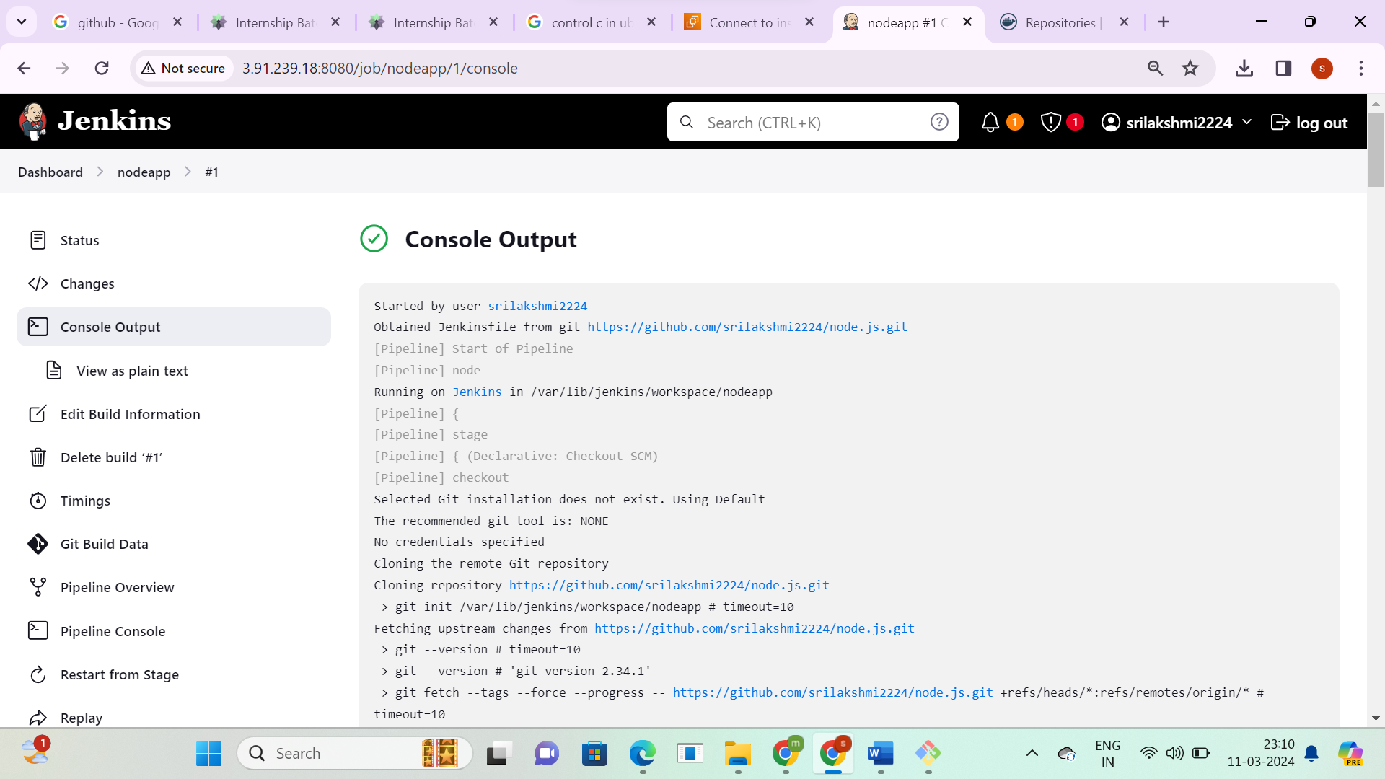

**This is the created docker image**

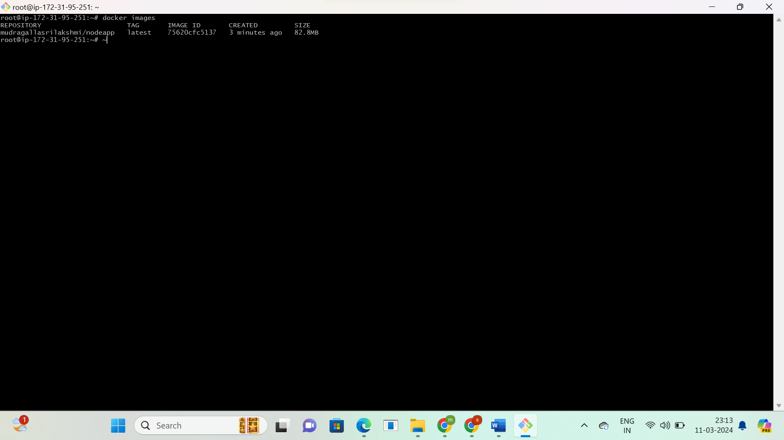

**Docker image is pushed into the Docker Hub using Jenkins file.**

